PROJECT DESIGN PHASE-II
Data Flow Diagram & User Stories
Date | 30 September 2026
Team ID | SWTID-2026-6529
Project Name | LegalEase
Team Size | 4
Team Leader | Sri Vijitha M
Team Members | Sree Harini P; Subalakshmi P; Sumaiya A
Maximum Marks | 4 Marks

1. Data Flow Diagrams
A Data Flow Diagram (DFD) represents how information enters, is processed by, and leaves the LegalEase system. The Level 0 DFD below shows the main user interaction, AI generation service, document formatting/export services, and final document outputs.
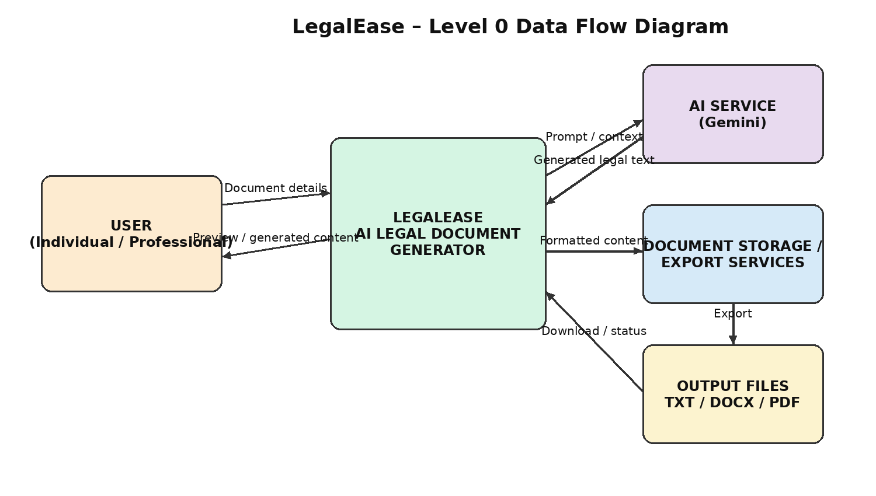

2. LegalEase Level 0 DFD – Components
- User: Provides document type, parties, terms and effective date and receives generated document content.
- LegalEase Application: Receives user input, validates it, prepares the generation request, displays the preview and coordinates document export.
- AI Service: Receives the structured prompt/context and returns generated legal-document content.
- Document Storage / Export Services: Formats generated content for downloadable document formats.
- Output Files: Final documents can be provided as TXT, DOCX and PDF.

3. Data Stores & Interfaces
ID | Component | Purpose
D1 | User Input / Request Data | Document type, parties, terms and effective date supplied by the user.
D2 | AI Generation Service | Processes the structured request and returns generated legal content.
D3 | Document Formatting Services | Converts generated content into TXT, DOCX and PDF output formats.
D4 | Generated Document Output | Provides the final document for preview, editing and download.

4. User Stories
User Type | Functional Requirement (Epic) | User Story Number | User Story / Task | Acceptance Criteria | Priority | Release
User | Document Input | USN-1 | As a user, I can enter the document type so that LegalEase knows which legal document I want to generate. | Valid document type is accepted and used in the generation request. | High | Sprint-1
User | Document Input | USN-2 | As a user, I can enter the parties involved, terms and effective date so that the generated document reflects my requirements. | Required inputs are accepted and passed to the generation workflow. | High | Sprint-1
User | AI Legal Document Generation | USN-3 | As a user, I can generate a structured legal document from my supplied details using the configured AI service. | Generated content contains relevant sections based on the supplied inputs. | High | Sprint-1
System | Input Validation & Sanitization | USN-4 | As the system, I must validate and safely handle incomplete, invalid or unsafe user input before processing. | Invalid or unsafe input is rejected, sanitized or handled safely. | High | Sprint-1
User | Document Preview | USN-5 | As a user, I can preview the generated legal document before downloading it. | Generated content is displayed in a readable and structured preview. | High | Sprint-2
User | Document Editing | USN-6 | As a user, I can edit the generated document before saving or downloading it. | User edits are retained and reflected in the exportable document. | High | Sprint-2
User | DOCX Export | USN-7 | As a user, I can download the generated document as a formatted DOCX file. | DOCX opens successfully and preserves expected headings, content, branding and terms formatting. | High | Sprint-2
User | PDF Export | USN-8 | As a user, I can download the generated document as a formatted PDF file. | PDF opens successfully and contains the generated content and expected formatting. | High | Sprint-2
User | TXT Export | USN-9 | As a user, I can download the generated or edited document as a TXT file. | TXT file downloads successfully and contains the document text. | Medium | Sprint-3
User | Legal Document Templates | USN-10 | As a user, I can generate different legal document types such as contracts, NDAs, lease agreements and employment documents. | The selected document type produces a suitable structured document. | High | Sprint-3
System | AI Failure Handling | USN-11 | As the system, I must handle an AI generation failure without producing corrupted or unintended document output. | A controlled error is shown and invalid output is not presented as a completed document. | Medium | Sprint-3
Team | Integration & UAT Validation | USN-12 | As a project team, we can validate the complete LegalEase workflow and prepare the final project documentation. | End-to-end workflow is tested and UAT feedback/sign-off is recorded. | High | Sprint-4

5. User Story Summary by Sprint
Sprint | User Stories | Focus | Priority
Sprint-1 | USN-1 to USN-4 | Input, AI generation, validation and sanitization | High
Sprint-2 | USN-5 to USN-8 | Preview, editing, DOCX and PDF export | High
Sprint-3 | USN-9 to USN-11 | TXT export, templates and AI failure handling | Medium / High
Sprint-4 | USN-12 | Integration, UAT and documentation | High

6. Team Details
Team ID | SWTID-2026-6529
Team Leader | Sri Vijitha M
Team Member | Sree Harini P
Team Member | Subalakshmi P
Team Member | Sumaiya A

7. Conclusion
The LegalEase Level 0 DFD represents the flow from user-provided legal-document details through the LegalEase application and AI generation service to preview, editing and final document export. The user stories define the major functional requirements and acceptance criteria for implementation across four planned sprints.

8. Sign-Off
Team Leader | Sri Vijitha M
Signature | ________________________________________
Date | ________________________________________
Faculty / Project Guide | ________________________________________
Signature | ________________________________________

